Multiple-choice section

|  |  |  |  |  |  |  |  |  |
| --- | --- | --- | --- | --- | --- | --- | --- | --- |
| Question | 1 | 2 | 3 | 4 | 5 | 6 | 7 | 8 |
| Answer | C | C | C | D | C | D | B | C |

Question 1 [5.1]

C

6*q* + 3 = 15

6*q* + 3 − 3 = 15 − 3

6*q* = 15 − 3 (subtract 3 from 15)

6*q* = 12

 =  (divide the answer by 6)

*q* = 2

Question 2 [5.2]

C

If *x* is the number of boys, then the number of girls is *x* + 6.

The number of boys and girls in the class is 32.

*x* + *x* + 6 = 32

2*x* + 6 = 32

Question 3 [5.3]

C



Question 4 [5.4]

D

Substitute *c* = 1 into the equation to find the value of *d*.

*d* = 4*c* + 6

= 4 × 1 + 6

= 4 + 6

= 10

Question 5 [5.5]

C

gradient = 

Question 6 [5.6]

D

The product of the gradients of perpendicular lines is -1: *m*1 × *m*2 = -1

The gradient of *y* = 4*x* + 3 is 4.

The general equation of a straight line is *y* = *mx* + *c*, so substitute *m1* = 4:

4 × *m*2 = -1

*m*2 = 

Question 7 [5.7]

B

Substitute values for the *x*-coordinates into the equation of the line and see whether the   
*y*-coordinate is obtained.

When *x* = 2:

*y* = 2 − 3 × 2

*y* = 2 − 6

*y* = -4

The point (2, -4) lies on the line.

Question 8 [5.8]

C

a vertical line passing through *x* = -5

a horizontal line passing through *y* = 6

Multiple-choice total marks: 8

Short answer section

Question 9 3 marks [5.1]

3(3*x* − 1) = 12

9*x* + 3 = 12

9*x* + 3 – 3 = 12 – 3

9*x* = 9

 = 

*x* = 1

Question 10 4 marks [5.2]

Let *D* be Daniel’s age. Gillian is three times Daniel’s age, so let 3*D* be Gillian’s age.

If the sum of their ages is 36, then:

*D* + 3*D* = 36

4*D* = 36

= 

*D* = 9

Daniel is 9 years old.

Since Gillian = 3*D*, then Gillian is 3  9 = 27 years old.

Question 11 3 marks [5.3]

Let (*x*1, *y*1) = (3, 7) and (*x*2, *y*2) = (5, 13)

Here, *x*1 = 3, *x*2 = 5, *y*1 = 7, *y*2 = 13

Write the midpoint formula, substitute in the relevant values, and evaluate.



*M* = (5, 10)

Question 12 4 marks [5.4]

(a)

|  |  |  |  |  |
| --- | --- | --- | --- | --- |
| n | 0 | 1 | 2 | 3 |
| m | 6 | 4 | 2 | 0 |

**(b)**

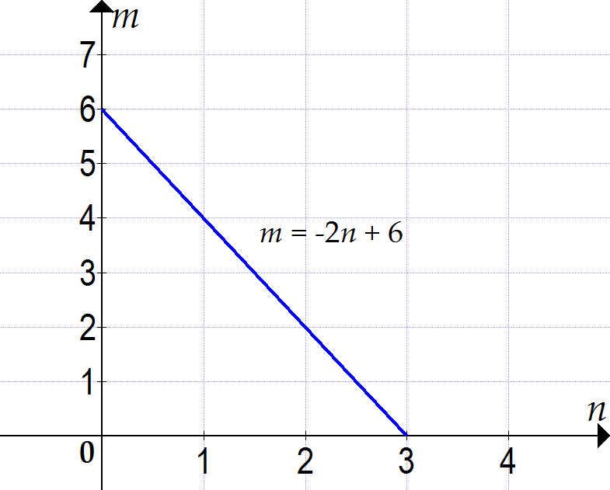

Question 13 3 marks [5.5]

*m* = 

= 

The points are (-2, -4) and (1, 2).

Let *x*1 = -2, *x*2 = 1, *y*1 = -4, *y*2 = 2



*m* = 2

Question 14 4 marks [5.6]

(a) *m* = 2, *b* = -6

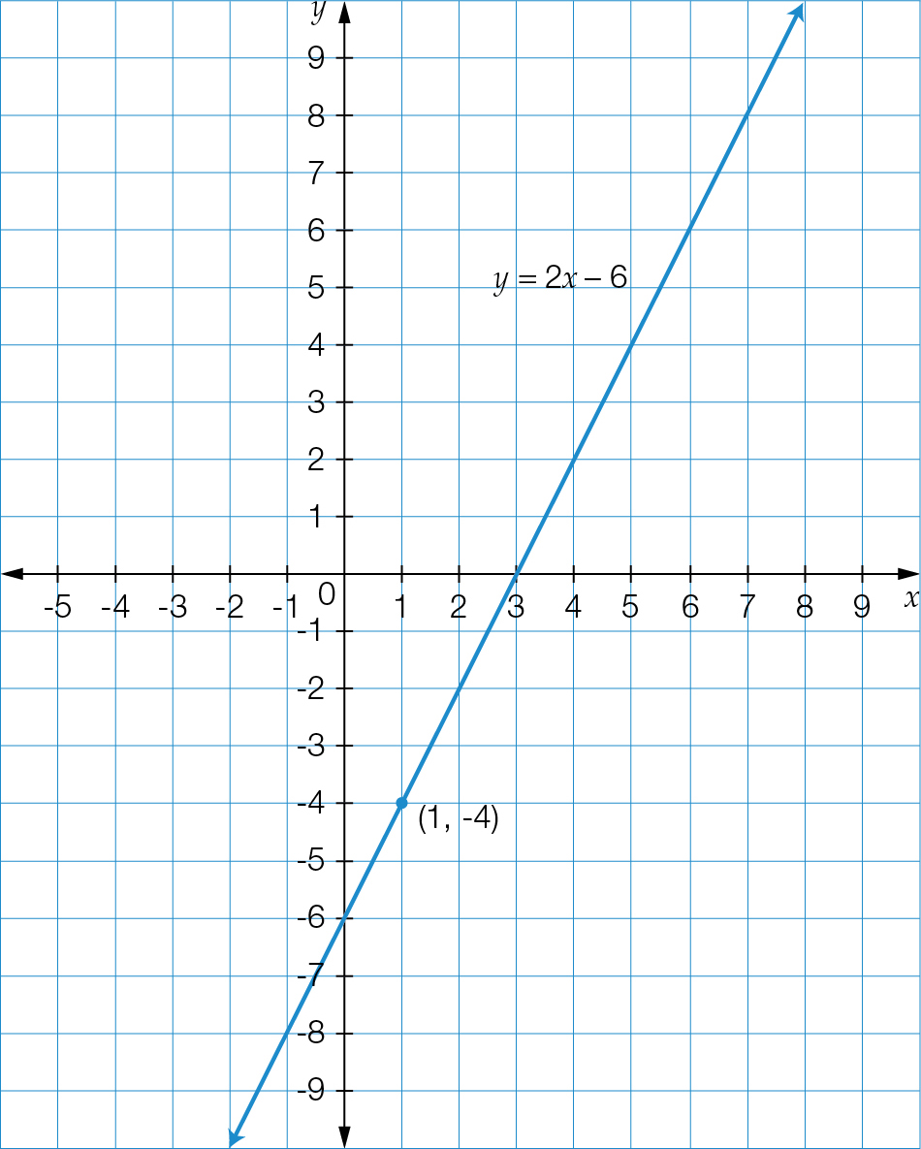

Question 15 4 marks [5.7]

6*x* + 2*y* = 12

*x*-intercept:

*y* = 0

6*x* + 0 = 12

*x* = 2

*x-*intercept= (2, 0)

*y-*intercept:

*x* = 0

6  0 + 2*y* = 12

2*y* = 12

*y* = 6

*y*-intercept = (0, 6)

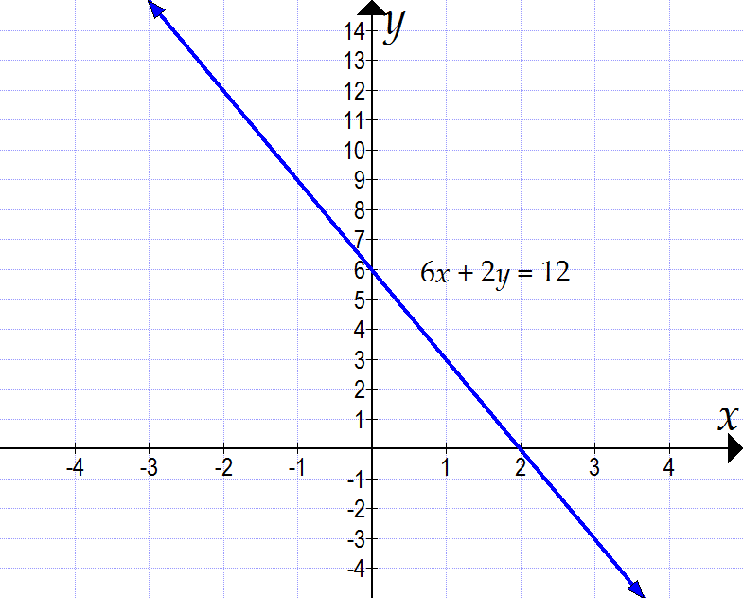

Question 16 2 marks [5.8]

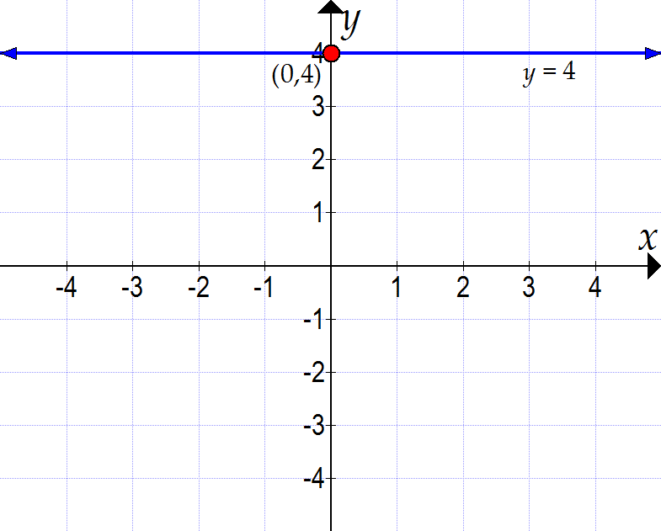

Short answer total marks: 27

Extended answer section

Question 17 2 + 2 + 3 +3 + 2 marks [5.2, 5.4, 5.5]

(a)

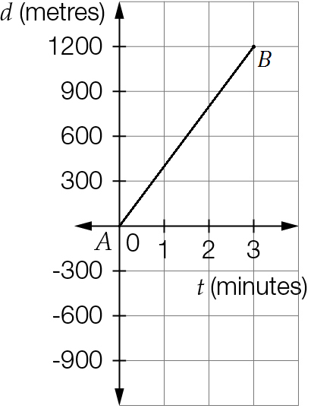

(b) *m* = 

= 

The points are (0, 0) and (3, 1200).

Let *x*1 = 0, *x*2 = 3, *y*1 = 0, *y*2 = 1200



*m* = 400

As *m* = , the units are *m* = , or metres per minute.

(c) Using *y* = *mx* + *c*, or *d* = *mt* + *c*:

*c* = 0, *m* = 400

Substitute into *d* = *mt* + *c*:

*d* = 400*t* + 0

*d* = 400*t*

(d) *d* = 400*t*

Substitute *d* = 10 000 m (10 km).

10 000 = 400*t*

 = 

25 = *t*, or *t* = 25 minutes

(e) Substitute 0, 1, 2, 3, 4, 5 into *d* = 400*t* to complete the table.

|  |  |  |  |  |  |  |
| --- | --- | --- | --- | --- | --- | --- |
| t | 0 | 1 | 2 | 3 | 4 | 5 |
| d | 0 | 400 | 800 | 1200 | 1600 | 2000 |

Question 18 2 + 3 + 3 + 3 marks [5.3, 5.4, 5.6]

(a)

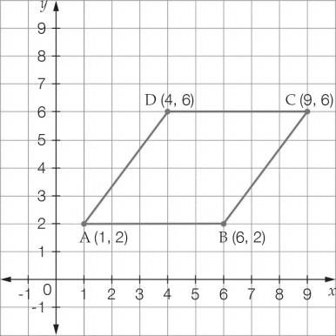

(b) Let *A*(*x*1, *y*1) = (1, 2) and *B*(*x*2, *y*2) = (4, 6)

Here, *x*1 = 1, *x*2 = 4, *y*1 = 2, *y*2 = 6

Write the distance formula, substitute in the relevant values, and evaluate. Include units in your answer.



*AB* = 5 units

(c) Side *CD* is parallel to the *x*-axis, i.e. it is a horizontal line. Its equation is *x* = 6.

(d)

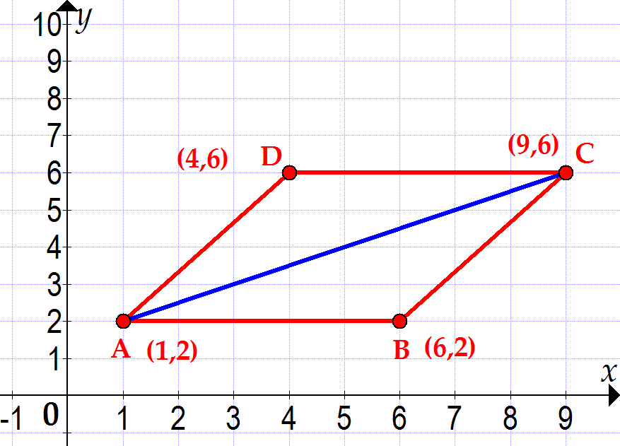

Diagonal *AC*:

Let (*x*1, *y*1) = (1, 2) and (*x*2, *y*2) = (9, 6)

Here, *x*1 = 1, *x*2 = 9, *y*1 = 2, *y*2 = 6

Write the midpoint formula, substitute in the relevant values, and evaluate.



*MAC* = (5, 4)

Extended answer total marks: 23

TOTAL test marks: 58